

**BALDIVIS SECONDARY COLLEGE**

**APPLICATIONS - Unit 3 & 4**

**2022 Test 1 - Bivariate Data**

Student Name ______________________ Teacher Name ______________________

**Time allowed for this task:** 55 minutes, in-class, test conditions.

Section 1: 20 minutes + 2 minutes reading time

Section 2: 30 minutes + 3 minutes reading time

**Materials required:** Section 1 Resource free section (19 marks)

Standard writing equipment

SCSA Formula Sheet

Section 2 Calculator assumed section (30 marks)

Calculator (to be supplied by the student)

SCSA formula Sheet

One page A4 (single sided) hand written notes

**Other materials allowed:** Drawing templates

**Marks available:** **49 marks**

**Task Weighting: 6%**

**Section 1: Resource Free [19 marks]**

Question 1. (1,2,3,2: 8 marks)

The scatterplot and least-squares line for a set of bivariate data (a, b) with correlation coefficient 0.85 is shown.

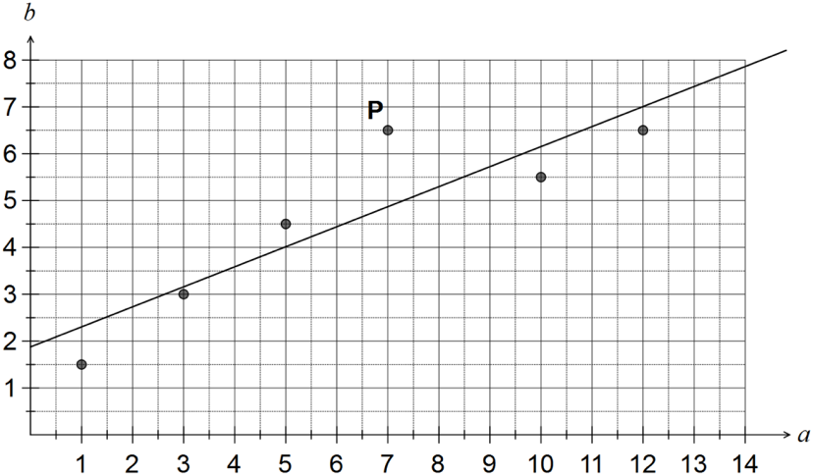

a) Describe the effect on the correlation coefficient if the point labelled P was removed from the dataset.

(b)   Describe the effect on the least-squares line if all data points with *a* < 4 were removed from the dataset.

(c)   Construct a residual plot for the six paired values on the axes below.

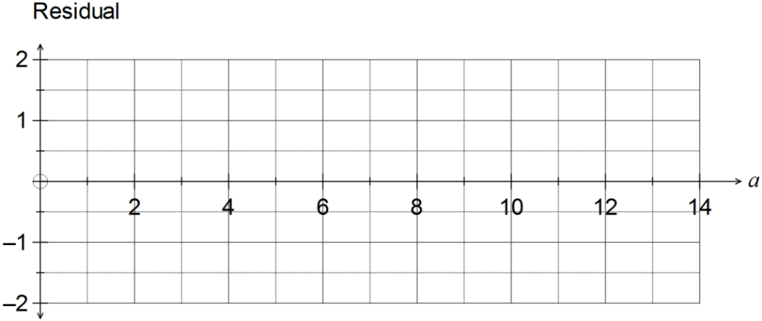

(d) Comment, with reasons, on the appropriateness of fitting a linear model to this dataset.

|  |  |  |  |  |  |  |  |  |  |  |  |  |  |  |  |  |  |  |  |  |
| --- | --- | --- | --- | --- | --- | --- | --- | --- | --- | --- | --- | --- | --- | --- | --- | --- | --- | --- | --- | --- |
| **Question 2.**  **(1,2: 3 marks)**  The table below shows some information about car accidents in Australia. It shows the percentage of car accidents by type of road being driven on, for three different age groups.   |  |  |  |  | | --- | --- | --- | --- | | Type of road | Age of driver in car accident | | | | 18 to 30 years | 31 to 50 years | Over 50 years | | Inner city | 43% | 51% | 17% | | Country | 32% | 32% | 48% | | Freeway | 25% | 17% | 35% | |  |
|  |  |

a) Of the car accidents involving drivers over 50 years of age, what percentage occurred on country roads or freeways?

b) Does the information in the table support the opinion that the age of drivers in car accidents is associated with the type of road on which they were driving? Justify your answer by quoting appropriate percentages from one age group only.

**Question 3.** **(2 marks)**

For the following sets of variables, state which is the explanatory variable and which is the response variable.

a) Amount of daily exercise and fitness level

b) Price for which a car sells and the age of the car

**Question 4 (2,1,2 = 6marks)**

After reading in the paper about the increased rate of criminal activity in beach suburbs, Freda decided to investigate some statistics for a popular beach suburb. She used data from the website for the Western Australia Police and examined the relationship between the number of assaults and the number of burglaries each month. Using a spreadsheet package she produced the following display.



1. Describe the strength of the linear relationship between the two variables. Justify your conclusion.

(b) The linear relationship between the two variables is described by the equation provided.

(i) What does this equation indicate is the approximate number of burglaries in a given month when there are no assaults?

(ii) What does this equation indicate would be the rate of change in the number of burglaries as the number of assaults increase?

**Section 2: Resource Allowed 30 marks**

**Question 5** **(2, 2, 2, 2, 2, 1: 11 marks)**

Data was collected from a rugby team to investigate whether there is a relationship between a player’s weight (kg) and their chest size (cm). The results are displayed in the table below.

|  |  |  |  |  |  |  |  |  |  |  |  |  |  |  |
| --- | --- | --- | --- | --- | --- | --- | --- | --- | --- | --- | --- | --- | --- | --- |
| **Weight** | 70 | 75 | 80 | 81 | 85 | 87 | 90 | 91 | 95 | 101 | **102** | **105** | **115** | **120** |
| **Chest size** | 79 | 75 | 85 | 80 | 86 | 90 | 97 | 92 | 98 | 100 | **99** | **103** | **102** | **123** |

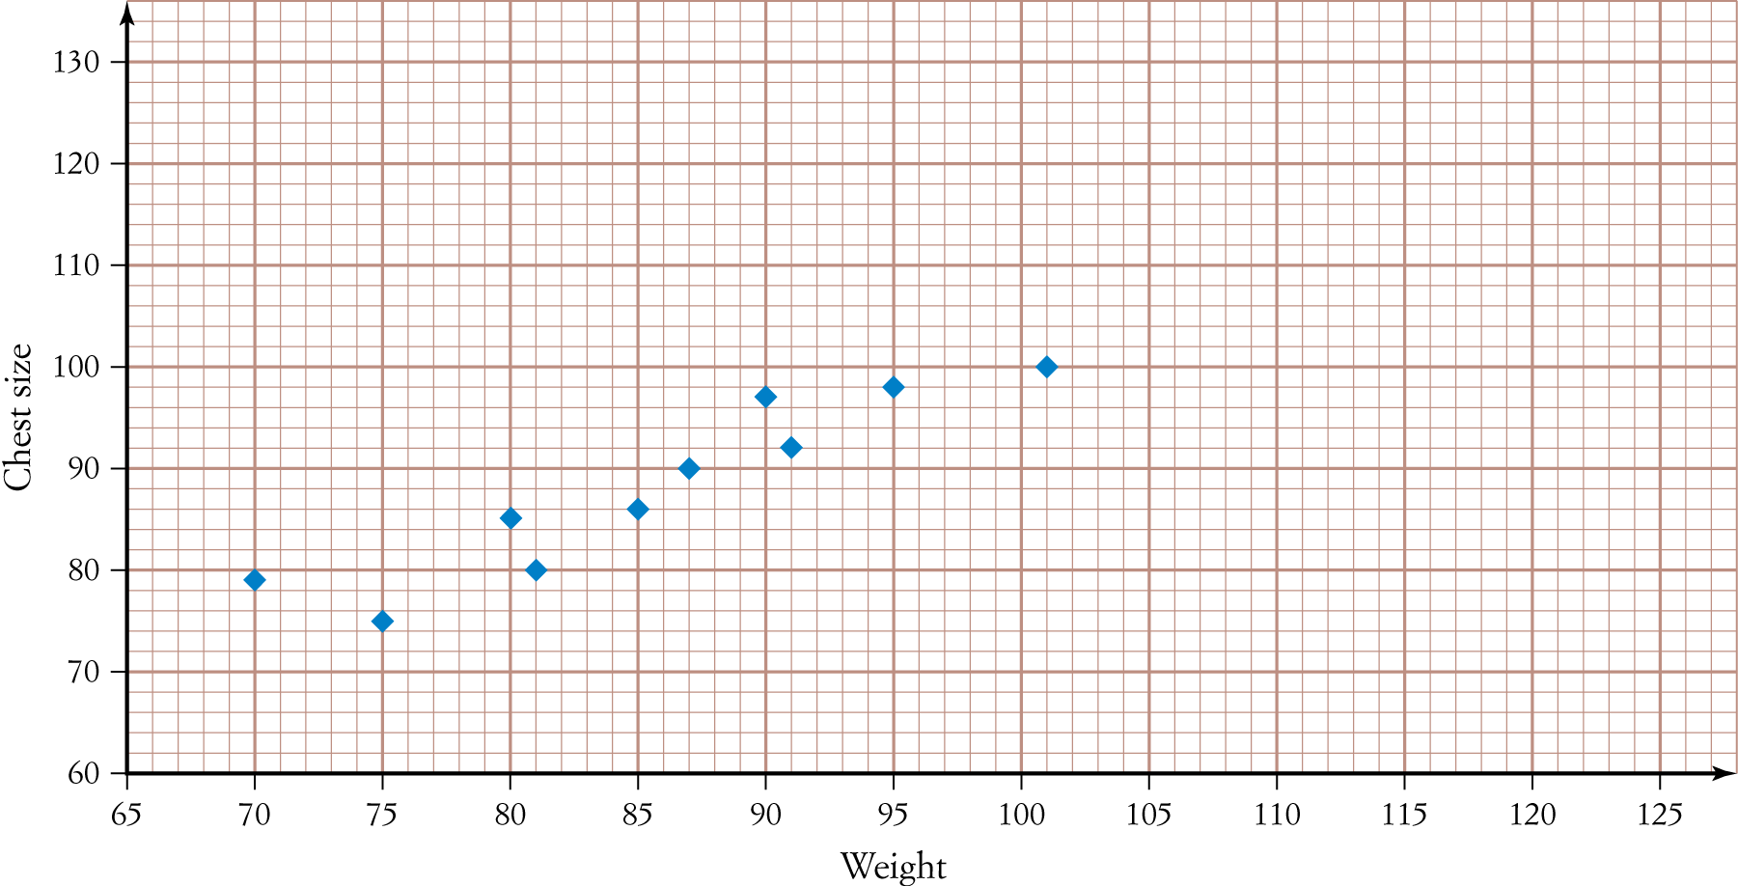a) Add the last four data points from the table (**in bold**) to the scatter plot below.

b) Calculate the least-squares regression line that models the data, stating all coefficients correct to two decimal places.

c) Hence, sketch the regression line onto the scatter plot in part **a**.

d) Calculate all the residual values (to one decimal place) for the data and complete the table below.

|  |  |  |  |  |  |  |  |  |  |  |  |  |  |  |
| --- | --- | --- | --- | --- | --- | --- | --- | --- | --- | --- | --- | --- | --- | --- |
| **Weight** | 70 | 75 | 80 | 81 | 85 | 87 | 90 | 91 | 95 | 101 | 102 | 105 | 115 | 120 |
| **Residual** | 3.6 |  |  | -4.2 |  |  | 5.6 |  |  | -0.2 |  |  | -9.3 | 7.7 |

1. 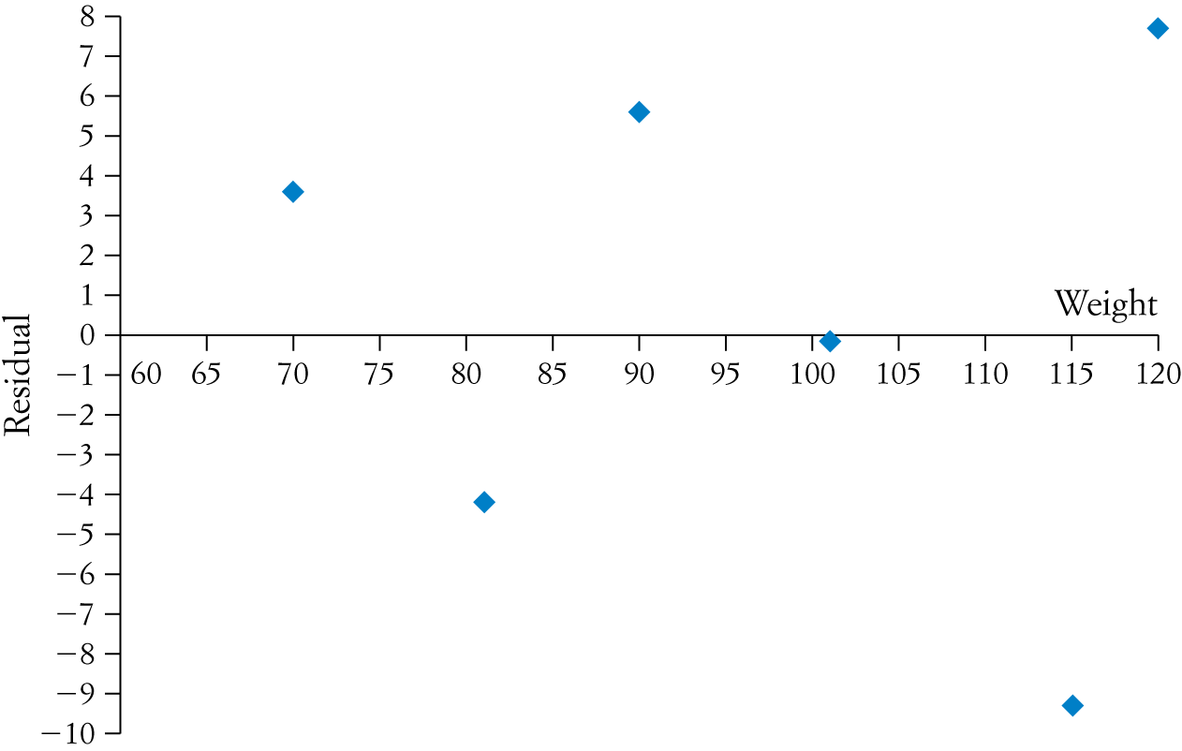Hence, complete the residual plot below.
2. Using the residual plot, justify whether the regression model found in part **b** is appropriate.

**Question 6 [4,1,1,4 =10 marks]**

The table below represents the results of a survey that determined the age of the survey participants and whether or not they were blood donors.

(a) Complete the two-way table:

|  |  |  |  |
| --- | --- | --- | --- |
|  |  | | |
|  | Blood Donor | Non-donor |  |
| 16 – 18 years | 8 |  | 25 |
| 19 – 25 years | 17 | 42 |  |
| 26 – 40 years | 29 |  |  |
| 41 – 65 years |  | 33 | 42 |
|  |  | 143 |  |

(b) How many 26–40 year olds were surveyed?

(c) How many of the participants surveyed were blood donors?

(d) Convert the two-way table to a percentage two-way table.

|  |  |  |  |
| --- | --- | --- | --- |
|  |  | | |
|  | Blood Donor | Non-donor |  |
| 16 – 18 years |  |  |  |
| 19 – 25 years |  |  |  |
| 26 – 40 years |  |  |  |
| 41 – 65 years |  |  |  |
|  |  |  |  |

**Question 7 (2,1,2 = 5marks)**

The least squares regression line between M and s is given by $M=0.07s+3.24$.

1. Find the average increase in M corresponding to an increase of 30 units in s.
2. Predict the value of M when s=60
3. The actual value of M when s=60 is 6.32. Find the residual associated with the prediction in b).

**Question 8** **(2, 2= 4 marks)**

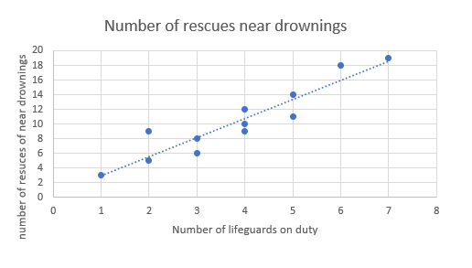

1. Comment on the relationship between the number of lifeguards on duty and the number of rescues of near drownings.
2. Jodie calculated the value of the correlation coefficient for the given data to be 0.96 (to 2.d.p.) and concluded that the more lifeguards were on duty, the more near drowning rescues occurred and hence it was probably better to reduce the number of lifeguards on duty. Discuss Jodie’s conclusions.